Alumni Core 40 Gear
Is your Core 40 shirt getting worn, small? If you were a member of the Core 40 at some point during your years at Woodland, take a look at our new line of Alumni wear. You can order short or long sleeved shirts and hoodies. Please get your orders to me soon, so we can have them by UNLESS 2019.
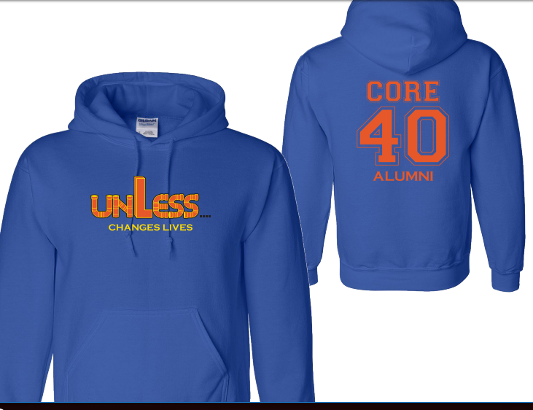

- - - - - - - - - - - - - - - - - - - - - - - - - - - - - - - - - - -

Name:_________________________ Cell Number:____________

Email:___________________________

Clothing Style | Cost | Adsm | Adm | Adlg | Adxl | Ad2x
Short Sleeves | $12.00
Long Sleeves | $16.00
Hoodie | $23.00
Total Cost

Please make checks payable to Woodland Intermediate School.
Order Forms Due Date to Woodland: April 23, 2019

Delivery: They will be delivered to Woodland around May 13, 2019 to be picked up. You can pick them up on the day of Unless or before. Just let me know. 920-810-1108

